Terraform challenge-3
Goal of the Exercise
The goal of this exercise is to test your understanding of a Cloud Compute deployment with Terraform.
You are tasked with creating a codebase for a microservice deployment on a cloud environment, using Terraform. Since our focus is not the application itself, the service will be a simple web server that returns a static page.

Requirements
Service Details

The service will be a simple web server that returns a static page.
You can useapache2ornginxto serve a simple HTML file.
The service should be containerized and stored in a Docker registry.
The service should be deployed on a single VM instance as a docker container.
The image should be pulled from the registry specified earlier.
The service should not be accessible from the internet but only through a Load Balancer, except for SSH access from specific IP addresses.

Deliverables
You are to provide the following as part of your solution:

Dockerfile to build the image.
Terraform codebase to deploy the following:
Docker registry
VPC and all required networking resources
EC2 instance
Load Balancer

Notes

Since a CI/CD pipeline is not part of this exercise, we will work around that with the help of Terraform.
To push the image to the Docker registry, build the image locally before running the Terraform code.
Once the image registry is created, use Terraform to push the local image to the registry.
Similarly, use Terraform to pull the image from the registry and run it on the VM instance once it is created.
For SSH access:
Use a locally created key.
Add it to the cloud provider key storage.
Attach it to the instance.

Use Terraform best practices for file structure and code organization.
Use variables, locals, modules, etc. when appropriate.

Include all tfvars, scripts, and other helper files used to deploy the application.
You may use any cloud provider of your choosing, although AWS is preferred.
Use a free tier account or atrial account to deploy the resources.

Objective:
To design and deploy a containerized microservice on AWS using Terraform. The exercise provisions an AWS VPC with networking components, an Amazon ECR Docker registry, an EC2 instance running the containerized Apache web server, and an Application Load Balancer. Security groups are configured so that the application is accessible only through the Load Balancer, while SSH access to the EC2 instance is restricted to an approved IP address.
1. Architecture:
Internet
|
| HTTP :80
v
+----------------+
| Public ALB |
| Port 80 |
+-------+--------+
|
ALB Security Group
|
| HTTP :80
v
+-----------------------+
| EC2 Instance |
| Docker Container |
| Apache :80 |
+-----------------------+
| |
| SSH :22 | Docker Pull
| |
Your IP only v
+----------+
| AWS ECR |
+----------+

VPC
|
+-- Public Subnet AZ-a
| |
| +-- ALB
|
+-- Public Subnet AZ-b
| |
| +-- EC2
|
+-- Internet Gateway

2. Project Structure
Use this structure:
terraform-microservice/
│
├── Dockerfile
├── index.html
├── terraform.tfvars
├── variables.tf
├── locals.tf
├── providers.tf
├── main.tf
├── outputs.tf
├── versions.tf
├── .gitignore
│
├── scripts/
│ └── user_data.sh
│
└── modules/
│
├── network/
│ ├── main.tf
│ ├── variables.tf
│ └── outputs.tf
│
├── security/
│ ├── main.tf
│ ├── variables.tf
│ └── outputs.tf
│
├── ecr/
│ ├── main.tf
│ ├── variables.tf
│ └── outputs.tf
│
├── compute/
│ ├── main.tf
│ ├── variables.tf
│ └── outputs.tf
│
└── alb/
├── main.tf
├── variables.tf
└── outputs.tf

This demonstrates Terraform best practices:
- Root module
- Child modules
- Variables
- Locals
- Outputs
- Data sources
- User-data script
- Separate networking/security/compute/load-balancer code

3. Dockerfile
The application is intentionally simple.

Dockerfile
FROM httpd:2.4-alpine

COPY index.html /usr/local/apache2/htdocs/index.html

EXPOSE 80

CMD ["httpd", "-D", "FOREGROUND"]

index.html
<!DOCTYPE html>
<html>
<head>
<title>Terraform Microservice</title>
</head>
<body>
<h1>Hello from Terraform Microservice!</h1>
<p>Application is running inside Docker on AWS EC2.</p>
</body>
</html>

4. Terraform Provider

versions.tf
terraform {
required_version = ">= 1.5.0"

required_providers {
aws = {
source = "hashicorp/aws"
version = "~> 6.0"
}
}
}

providers.tf
provider "aws" {
region = var.aws_region
}
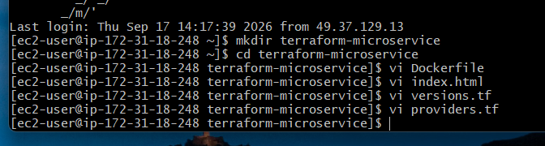
Configure AWS credentials before starting:
aws configure
Use:
AWS Access Key ID: <your-access-key>
AWS Secret Access Key: <your-secret-key>
Default region name: us-east-1
Default output format: json
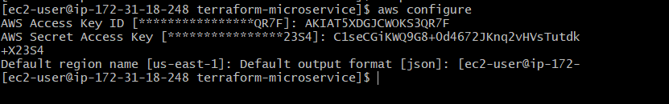

5. Variables

variables.tf
variable "aws_region" {
description = "AWS region"
type = string
default = "us-east-1"
}

variable "project_name" {
description = "Project name"
type = string
default = "terraform-microservice"
}

variable "ssh_allowed_cidr" {
description = "CIDR allowed to SSH into EC2"
type = string
}

variable "key_name" {
description = "AWS EC2 key pair name"
type = string
default = "terraform-microservice-key"
}

variable "public_key_path" {
description = "Path to SSH public key"
type = string
default = "./terraform-microservice-key.pub"
}

6. Locals

locals.tf
locals {
common_tags = {
Project = var.project_name
Environment = "dev"
ManagedBy = "Terraform"
}
}

7. Terraform Variables File

terraform.tfvars
Replace the CIDR with your own public IP.
For example:
aws_region = "us-east-1"

project_name = "terraform-microservice"

ssh_allowed_cidr = "YOUR_PUBLIC_IP/32"

key_name = "terraform-microservice-key"

public_key_path = "./terraform-microservice-key.pub"
If your public IP is:
49.205.100.50
then:
ssh_allowed_cidr = "49.205.100.50/32"
/32 means only that single IP.

8. Network Module

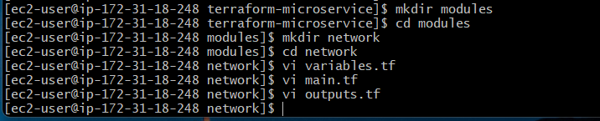

modules/network/variables.tf
variable "project_name" {
type = string
}

variable "common_tags" {
type = map(string)
}

modules/network/main.tf
data "aws_availability_zones" "available" {
state = "available"
}

resource "aws_vpc" "main" {
cidr_block = "10.0.0.0/16"
enable_dns_support = true
enable_dns_hostnames = true

tags = merge(
var.common_tags,
{
Name = "${var.project_name}-vpc"
}
)
}

resource "aws_internet_gateway" "main" {
vpc_id = aws_vpc.main.id

tags = merge(
var.common_tags,
{
Name = "${var.project_name}-igw"
}
)
}

resource "aws_subnet" "public_a" {
vpc_id = aws_vpc.main.id
cidr_block = "10.0.1.0/24"
availability_zone = data.aws_availability_zones.available.names[0]
map_public_ip_on_launch = true

tags = merge(
var.common_tags,
{
Name = "${var.project_name}-public-a"
}
)
}

resource "aws_subnet" "public_b" {
vpc_id = aws_vpc.main.id
cidr_block = "10.0.2.0/24"
availability_zone = data.aws_availability_zones.available.names[1]
map_public_ip_on_launch = true

tags = merge(
var.common_tags,
{
Name = "${var.project_name}-public-b"
}
)
}

resource "aws_route_table" "public" {
vpc_id = aws_vpc.main.id

route {
cidr_block = "0.0.0.0/0"
gateway_id = aws_internet_gateway.main.id
}

tags = merge(
var.common_tags,
{
Name = "${var.project_name}-public-rt"
}
)
}

resource "aws_route_table_association" "public_a" {
subnet_id = aws_subnet.public_a.id
route_table_id = aws_route_table.public.id
}

resource "aws_route_table_association" "public_b" {
subnet_id = aws_subnet.public_b.id
route_table_id = aws_route_table.public.id
}

modules/network/outputs.tf
output "vpc_id" {
value = aws_vpc.main.id
}

output "public_subnet_a_id" {
value = aws_subnet.public_a.id
}

output "public_subnet_b_id" {
value = aws_subnet.public_b.id
}

output "public_subnet_ids" {
value = [
aws_subnet.public_a.id,
aws_subnet.public_b.id
]
}

9. Security Groups
We need two security groups.

ALB SG
Internet
|
| :80
v
ALB

EC2 SG
ALB SG ------> EC2 :80

Your IP -----> EC2 :22
The EC2 SG does not allow HTTP from the internet.

modules/security/variables.tf
variable "vpc_id" {
type = string
}

variable "project_name" {
type = string
}

variable "ssh_allowed_cidr" {
type = string
}

variable "common_tags" {
type = map(string)
}

modules/security/main.tf
resource "aws_security_group" "alb" {
name = "${var.project_name}-alb-sg"
description = "Security group for Application Load Balancer"
vpc_id = var.vpc_id

ingress {
description = "HTTP from Internet"
from_port = 80
to_port = 80
protocol = "tcp"
cidr_blocks = ["0.0.0.0/0"]
}

egress {
description = "Allow outbound traffic"
from_port = 0
to_port = 0
protocol = "-1"
cidr_blocks = ["0.0.0.0/0"]
}

tags = merge(
var.common_tags,
{
Name = "${var.project_name}-alb-sg"
}
)
}

resource "aws_security_group" "ec2" {
name = "${var.project_name}-ec2-sg"
description = "Security group for EC2"
vpc_id = var.vpc_id

ingress {
description = "HTTP only from ALB"
from_port = 80
to_port = 80
protocol = "tcp"
security_groups = [aws_security_group.alb.id]
}

ingress {
description = "SSH from approved IP"
from_port = 22
to_port = 22
protocol = "tcp"
cidr_blocks = [var.ssh_allowed_cidr]
}

egress {
description = "Allow outbound traffic"
from_port = 0
to_port = 0
protocol = "-1"
cidr_blocks = ["0.0.0.0/0"]
}

tags = merge(
var.common_tags,
{
Name = "${var.project_name}-ec2-sg"
}
)
}

modules/security/outputs.tf
output "alb_security_group_id" {
value = aws_security_group.alb.id
}

output "ec2_security_group_id" {
value = aws_security_group.ec2.id
}
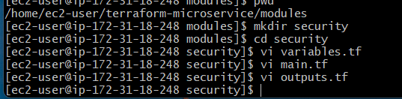

10. ECR Module
The Docker image will be stored in Amazon ECR.
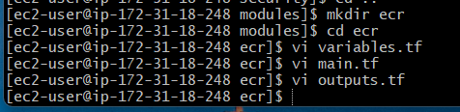

modules/ecr/variables.tf
variable "repository_name" {
type = string
}

variable "common_tags" {
type = map(string)
}

modules/ecr/main.tf
resource "aws_ecr_repository" "app" {
name = var.repository_name
image_tag_mutability = "MUTABLE"

image_scanning_configuration {
scan_on_push = true
}

tags = var.common_tags
}

modules/ecr/outputs.tf
output "repository_url" {
value = aws_ecr_repository.app.repository_url
}

output "repository_name" {
value = aws_ecr_repository.app.name
}

11. EC2 Module
We need:
- EC2
- IAM role
- Instance profile
- ECR permissions
- SSH key pair
- Docker installation
- ECR login
- Docker pull
- Docker container startup
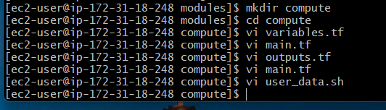

modules/compute/variables.tf
variable "project_name" {
type = string
}

variable "subnet_id" {
type = string
}

variable "security_group_id" {
type = string
}

variable "key_name" {
type = string
}

variable "public_key_path" {
type = string
}

variable "ecr_repository_url" {
type = string
}

variable "common_tags" {
type = map(string)
}

modules/compute/main.tf

Find Amazon Linux 2023
data "aws_ami" "amazon_linux" {
most_recent = true

owners = ["amazon"]

filter {
name = "name"
values = ["al2023-ami-*-x86_64"]
}

filter {
name = "state"
values = ["available"]
}
}

SSH key
resource "aws_key_pair" "app" {
key_name = var.key_name
public_key = file(var.public_key_path)

tags = var.common_tags
}

IAM role
resource "aws_iam_role" "ec2" {
name = "${var.project_name}-ec2-role"

assume_role_policy = jsonencode({
Version = "2012-10-17"

Statement = [
{
Effect = "Allow"

Principal = {
Service = "ec2.amazonaws.com"
}

Action = "sts:AssumeRole"
}
]
})

tags = var.common_tags
}

ECR permissions
resource "aws_iam_role_policy_attachment" "ecr" {
role = aws_iam_role.ec2.name
policy_arn = "arn:aws:iam::aws:policy/AmazonEC2ContainerRegistryReadOnly"
}

Instance profile
resource "aws_iam_instance_profile" "ec2" {
name = "${var.project_name}-instance-profile"
role = aws_iam_role.ec2.name
}

EC2 instance
resource "aws_instance" "app" {
ami = data.aws_ami.amazon_linux.id
instance_type = "t3.micro"
subnet_id = var.subnet_id
vpc_security_group_ids = [var.security_group_id]
key_name = aws_key_pair.app.key_name
associate_public_ip_address = true

iam_instance_profile = aws_iam_instance_profile.ec2.name

user_data = templatefile(
"${path.module}/user_data.sh",
{
ecr_repository_url = var.ecr_repository_url
}
)

tags = merge(
var.common_tags,
{
Name = "${var.project_name}-ec2"
}
)
}

modules/compute/user_data.sh
#!/bin/bash

set -e

dnf update -y

dnf install -y docker awscli

systemctl enable docker
systemctl start docker

usermod -aG docker ec2-user

REGION=$(TOKEN=$(curl -X PUT -s "http://169.254.169.254/latest/api/token" \
-H "X-aws-ec2-metadata-token-ttl-seconds: 21600") && \
curl -s "http://169.254.169.254/latest/meta-data/placement/region" \
-H "X-aws-ec2-metadata-token: $TOKEN")

aws ecr get-login-password --region "$REGION" | \
docker login --username AWS --password-stdin ${ecr_repository_url}

docker pull ${ecr_repository_url}:latest

docker rm -f microservice 2>/dev/null || true

docker run -d \
--name microservice \
--restart unless-stopped \
-p 80:80 \
${ecr_repository_url}:latest

modules/compute/outputs.tf
output "instance_id" {
value = aws_instance.app.id
}

output "private_ip" {
value = aws_instance.app.private_ip
}

output "public_ip" {
value = aws_instance.app.public_ip
}

12. ALB Module

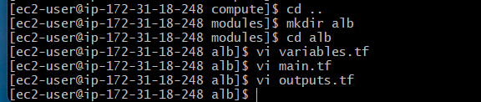

modules/alb/variables.tf
variable "project_name" {
type = string
}

variable "vpc_id" {
type = string
}

variable "subnet_ids" {
type = list(string)
}

variable "security_group_id" {
type = string
}

variable "instance_id" {
type = string
}

variable "common_tags" {
type = map(string)
}

modules/alb/main.tf

Load Balancer
resource "aws_lb" "app" {
name = "${var.project_name}-alb"
internal = false
load_balancer_type = "application"

security_groups = [
var.security_group_id
]

subnets = var.subnet_ids

tags = merge(
var.common_tags,
{
Name = "${var.project_name}-alb"
}
)
}

Target Group
resource "aws_lb_target_group" "app" {
name = "${var.project_name}-tg"
port = 80
protocol = "HTTP"
vpc_id = var.vpc_id

target_type = "instance"

health_check {
enabled = true
path = "/"
protocol = "HTTP"
port = "traffic-port"
healthy_threshold = 2
unhealthy_threshold = 2
timeout = 5
interval = 30
}

tags = var.common_tags
}

Register EC2
resource "aws_lb_target_group_attachment" "app" {
target_group_arn = aws_lb_target_group.app.arn
target_id = var.instance_id
port = 80
}

Listener
resource "aws_lb_listener" "http" {
load_balancer_arn = aws_lb.app.arn
port = 80
protocol = "HTTP"

default_action {
type = "forward"

forward {
target_group {
arn = aws_lb_target_group.app.arn
}
}
}
}

modules/alb/outputs.tf
output "dns_name" {
value = aws_lb.app.dns_name
}

output "load_balancer_arn" {
value = aws_lb.app.arn
}

13. Root Main Configuration

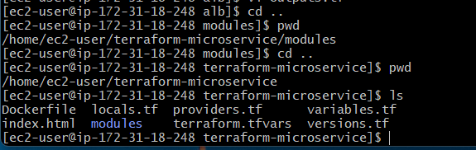
Now connect all the modules.
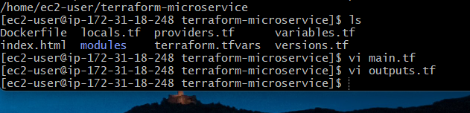

main.tf
module "network" {
source = "./modules/network"

project_name = var.project_name
common_tags = local.common_tags
}

module "security" {
source = "./modules/security"

vpc_id = module.network.vpc_id
project_name = var.project_name
ssh_allowed_cidr = var.ssh_allowed_cidr
common_tags = local.common_tags
}

module "ecr" {
source = "./modules/ecr"

repository_name = "${var.project_name}-repository"
common_tags = local.common_tags
}

module "compute" {
source = "./modules/compute"

project_name = var.project_name
subnet_id = module.network.public_subnet_a_id
security_group_id = module.security.ec2_security_group_id
key_name = var.key_name
public_key_path = var.public_key_path
ecr_repository_url = module.ecr.repository_url
common_tags = local.common_tags

depends_on = [
module.ecr
]
}

module "alb" {
source = "./modules/alb"

project_name = var.project_name
vpc_id = module.network.vpc_id
subnet_ids = module.network.public_subnet_ids
security_group_id = module.security.alb_security_group_id
instance_id = module.compute.instance_id
common_tags = local.common_tags
}

14. Outputs

outputs.tf
output "vpc_id" {
value = module.network.vpc_id
}

output "ecr_repository_url" {
value = module.ecr.repository_url
}

output "ec2_instance_id" {
value = module.compute.instance_id
}

output "ec2_public_ip" {
value = module.compute.public_ip
}

output "ec2_private_ip" {
value = module.compute.private_ip
}

output "alb_dns_name" {
value = module.alb.dns_name
}

output "application_url" {
value = "http://${module.alb.dns_name}"
}

15. Docker Image Build
There is an important point in the exercise.
The requirement says:
Build the image locally before running Terraform.
So first build the image locally.
From the project root:
docker build -t terraform-microservice:latest .
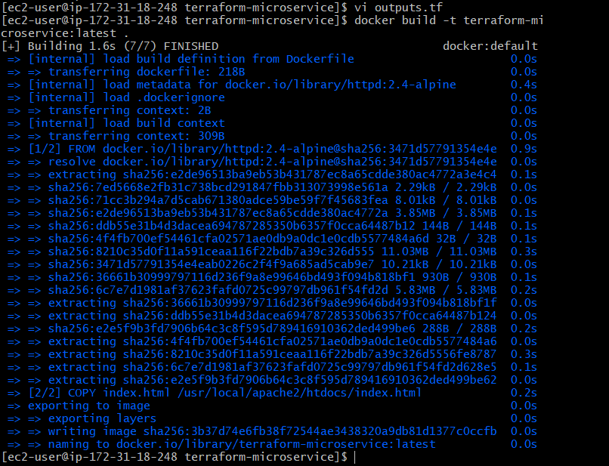
Verify:
docker images
You should see:
terraform-microservice latest
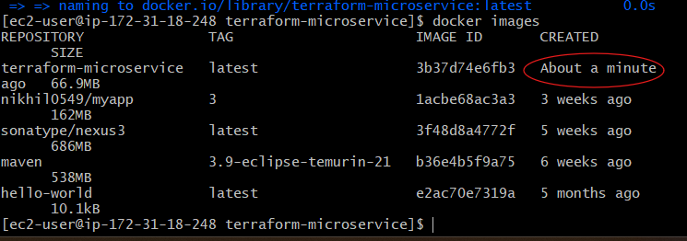
You can test locally:
docker run -d \
--name terraform-test \
-p 8083:80 \
terraform-microservice:latest
Then:
http://localhost:8083

You should see:
Hello from Terraform Microservice!
Application is running inside Docker on AWS EC2.
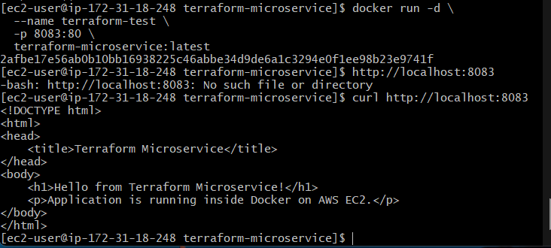
Remove the local test container:
docker rm -f terraform-test

16. Create the SSH Key
Because the requirement specifically says to use a locally created key, create it locally.
From Git Bash:
ssh-keygen -t rsa -b 4096 -f terraform-microservice-key
Press Enter when asked for the passphrase if you want a lab key without a passphrase.
You will have:
terraform-microservice
terraform-microservice.pub
The .pub file is uploaded to AWS by Terraform.
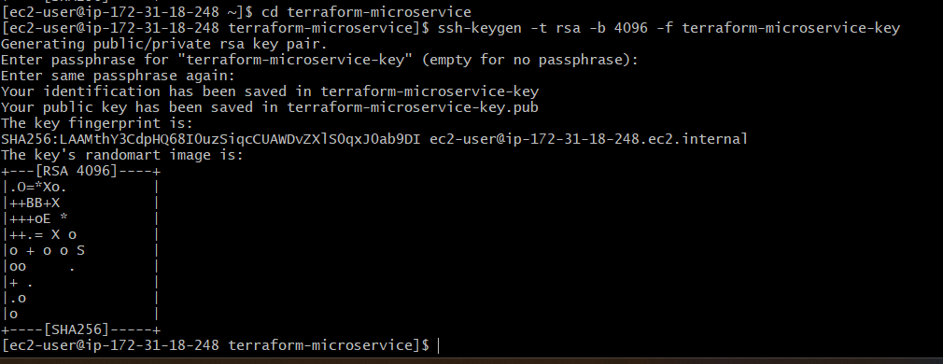
Do not commit the private key to Git.

17. .gitignore
Create:

.gitignore
.terraform/
*.tfstate
*.tfstate.*
*.tfvars
*.tfvars.json

terraform-microservice-key
terraform-microservice-key.pub

crash.log
crash.*.log
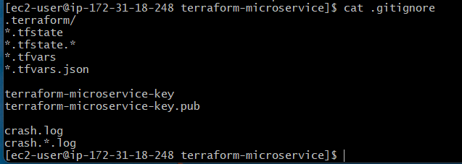
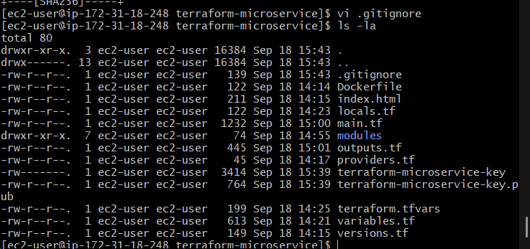

18. Terraform Initialization
Run:
terraform init
Expected:
Terraform has been successfully initialized!
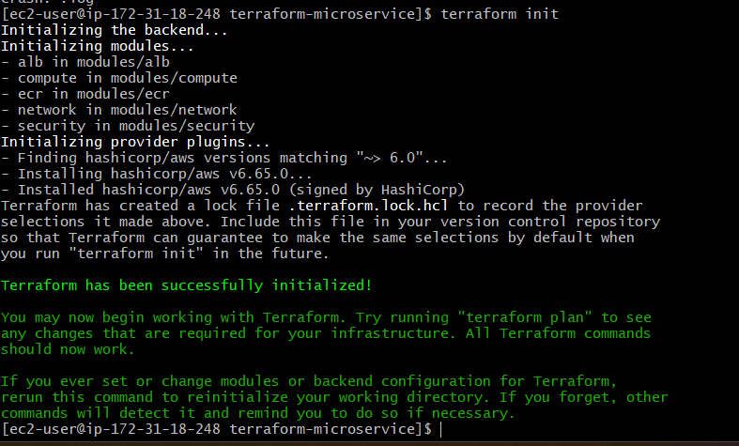
Then:
terraform fmt -recursive
Validate:
terraform validate
Expected:
Success! The configuration is valid.
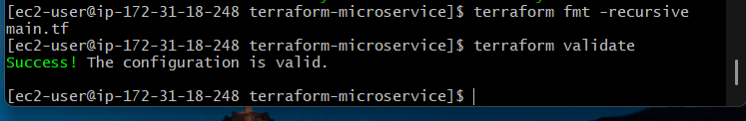

19. Terraform Plan
Run:
terraform plan
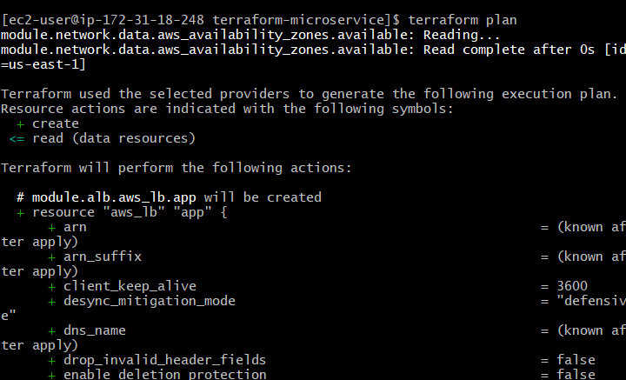

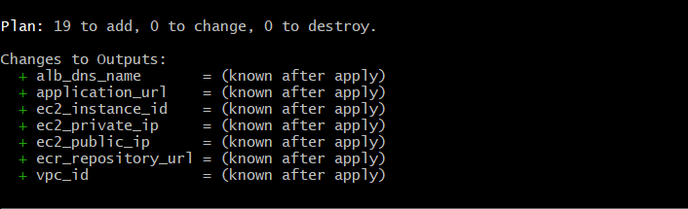
Terraform should show resources for:
VPC
Internet Gateway
2 Subnets
Route Table
Route Associations
ALB Security Group
EC2 Security Group
ECR Repository
IAM Role
IAM Policy Attachment
Instance Profile
Key Pair
EC2
ALB
Target Group
Target Group Attachment
ALB Listener

20. Important Part — Push Local Image to ECR
There is a dependency problem here.
You cannot push to ECR before the ECR repository exists.
Therefore the sequence is:
1. Build image locally
|
v
2. Terraform creates ECR
|
v
3. Login to ECR
|
v
4. Tag local image
|
v
5. Push image
|
v
6. Create EC2
|
v
7. EC2 pulls image
|
v
8. Docker container starts
For this exercise, I recommend handling the ECR push explicitly after ECR creation, rather than hiding the Docker push inside a null_resource. This is more reliable across Windows/Git Bash environments and easier to explain during an interview.
We will create only these resources first:
VPC
└── Networking

Security Groups

ECR Repository
We will not create EC2 or ALB yet.

20.1 Run this command
terraform apply -target=module.network -target=module.security -target=module.ecr
Terraform will show the resources it plans to create.
When it asks:
Do you want to perform these actions?
Terraform will perform the actions described above.
Only 'yes' will be accepted to approve.

Enter a value:
type:
yes
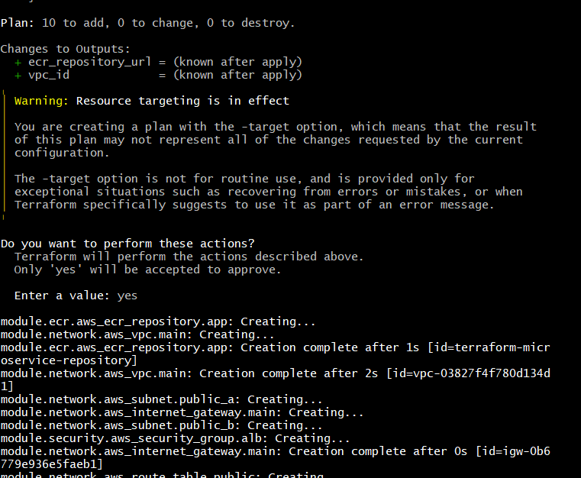

20.2 Wait for completion
You should eventually see something similar to:
Apply complete! Resources: XX added, 0 changed, 0 destroyed.
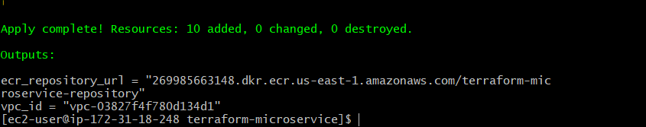
You should now have an ECR repository in AWS.

20.3 Get the ECR repository URL
Run:
terraform output ecr_repository_url
You should get something similar to:
123456789012.dkr.ecr.us-east-1.amazonaws.com/terraform-microservice-repos

21. Login to ECR
Now we will connect your local Docker to the ECR repository.

21.1 Get your ECR URL again
Run:
terraform output ecr_repository_url
You should get something like:
123456789012.dkr.ecr.us-east-1.amazonaws.com/terraform-microservice-repository
Copy this value.

21.2 Login to ECR
Because we are using us-east-1, run:
aws ecr get-login-password --region us-east-1 | docker login --username AWS --password-stdin YOUR_ECR_URL
Replace YOUR_ECR_URL with the URL from the previous command.
For example:
aws ecr get-login-password --region us-east-1 | docker login --username AWS --password-stdin 123456789012.dkr.ecr.us-east-1.amazonaws.com

Expected result
You should see:
Login Succeeded

Important
Do not include the repository name after the registry URL for the docker login command.
For example, if Terraform gives:
123456789012.dkr.ecr.us-east-1.amazonaws.com/terraform-microservice-repository
you login to:
123456789012.dkr.ecr.us-east-1.amazonaws.com
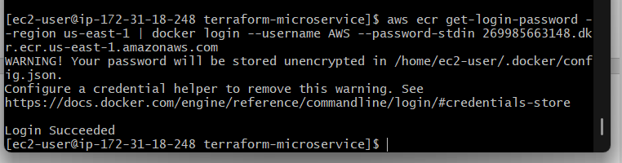

21.3 Verify Docker login
Run:
docker info
You don't need to look for anything specific; the important part is that the previous command returned:
Login Succeeded

22. Tag the Local Docker Image
Before pushing the image to ECR, Docker needs to know which ECR repository the image belongs to.

22.1 Check your local image
Run:
docker images
You should see something like:
REPOSITORY TAG IMAGE ID
terraform-microservice latest xxxxxxxxx
The important part is:
terraform-microservice:latest
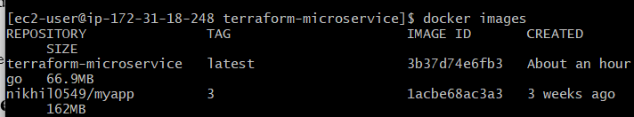

22.2 Get your ECR repository URL
Run:
terraform output ecr_repository_url
For example:
123456789012.dkr.ecr.us-east-1.amazonaws.com/terraform-microservice-repository

22.3 Tag the image
Use this command:
docker tag terraform-microservice:latest YOUR_ECR_URL:latest
For example:
docker tag terraform-microservice:latest 123456789012.dkr.ecr.us-east-1.amazonaws.com/terraform-microservice-repository:latest

What happened?
Originally your image was:
terraform-microservice:latest
After tagging:
terraform-microservice:latest
|
v
123456789012.dkr.ecr.us-east-1.amazonaws.com/terraform-microservice-repository:latest
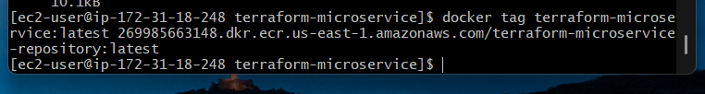
The image itself was not rebuilt.
We simply gave Docker another name for the same image so it knows where to push it.

22.4 Verify the tag
Run:
docker images
You should now see both names pointing to the same image ID:
REPOSITORY
terraform-microservice

123456789012.dkr.ecr.us-east-1.amazonaws.com/terraform-microservice-repository
The second one should have:
TAG
Latest
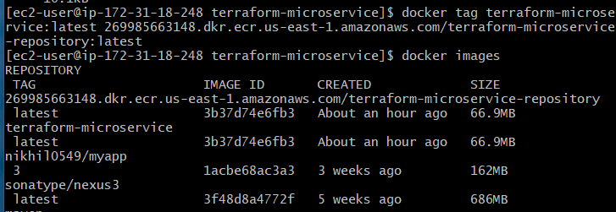

23. Push Docker Image to ECR
Now we will upload your Docker image from your laptop to AWS ECR.

23.1 Push the image
Use your exact ECR URL from:
terraform output ecr_repository_url
Then run:
docker push YOUR_ECR_URL:latest
For example:
docker push 123456789012.dkr.ecr.us-east-1.amazonaws.com/terraform-microservice-repository:latest
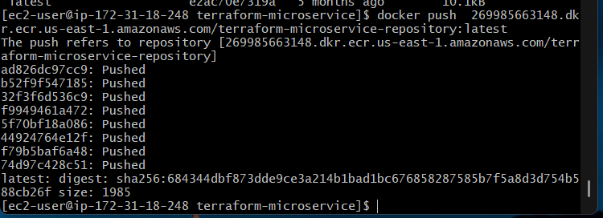

23.2 What Docker is doing
The process is:
Your Laptop
|
| Docker image
| terraform-microservice:latest
v
+----------------------------------+
| Amazon ECR |
| |
| terraform-microservice-repository|
| :latest |
+----------------------------------+
You should see output similar to:
The push refers to repository [...]
...
latest: digest: sha256:xxxxxxxx
The exact digest will be different for you.

23.3 Verify the image in ECR
Run:
aws ecr describe-images \
--repository-name terraform-microservice-repository \
--region us-east-1
You should see information containing:
"imageTags": [
"latest"
]
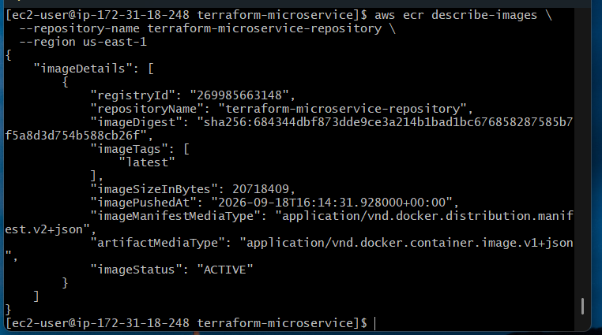
That confirms:
Docker image
↓
Local machine
↓
ECR
↓
latest

24. Create EC2 + ALB
Now we can deploy the remaining infrastructure.
Terraform will create:
EC2
├── Amazon Linux
├── Docker
├── IAM Role
├── SSH Key
└── Docker container
↑
|
ECR

ALB
└── Target Group
└── EC2:80

24.1 Run Terraform Apply
From your project directory:
terraform apply
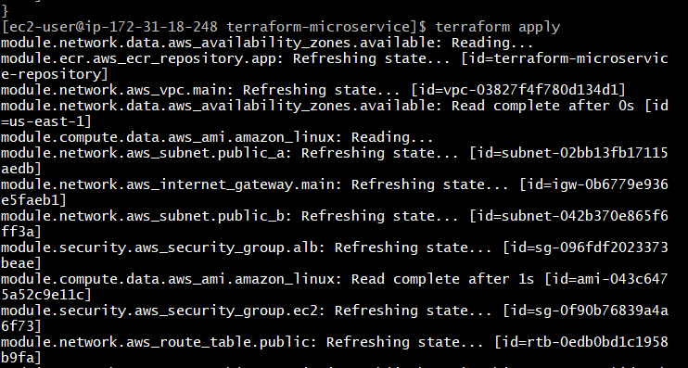
Terraform should detect that the VPC, security groups, and ECR already exist and create the remaining resources.
You'll see a plan similar to:
Plan: XX to add, 0 to change, 0 to destroy.
When Terraform asks:
Do you want to perform these actions?
Only 'yes' will be accepted to approve.
enter:
yes
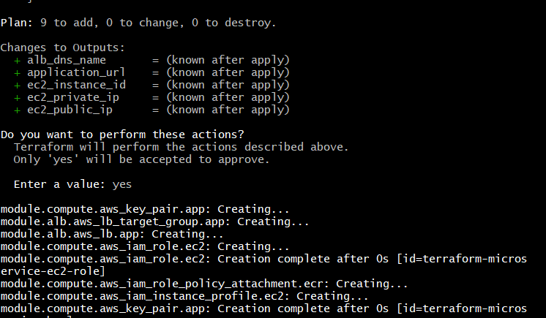

24.2 What happens on EC2 creation?
When EC2 starts, our user_data.sh runs automatically:
EC2 starts
|
v
Install Docker
|
v
Start Docker
|
v
Get AWS region
|
v
Login to ECR
|
v
docker pull <ECR_URL>:latest
|
v
docker run -d -p 80:80
|
v
Apache container running
So you do not need to SSH into the EC2 and manually install Docker or pull the image.

24.3 Wait for completion
At the end you should see:
Apply complete! Resources: XX added, 0 changed, 0 destroyed.
And Terraform should display outputs such as:
application_url = "http://..."
ec2_public_ip = "..."
ec2_private_ip = "..."
ecr_repository_url = "..."
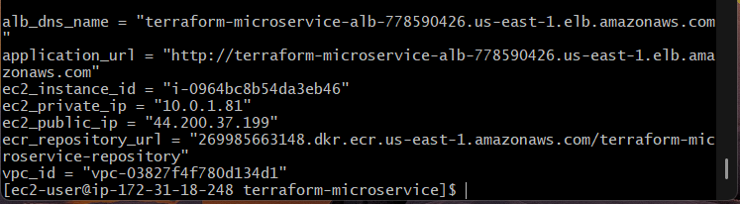

25 — Verify the EC2 Instance
First, let's confirm that the Docker container actually started correctly.

25.1 Get the EC2 public IP
Run:
terraform output ec2_public_ip
You should get something like:
34.xx.xx.xx
Copy that IP.
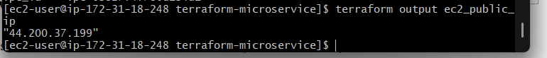

25.2 SSH into EC2
Use the private key you created in Step 16:
ssh -i terraform-microservice ec2-user@<EC2_PUBLIC_IP>
For example:
ssh -i terraform-microservice ec2-user@34.xx.xx.xx
If you see:
Are you sure you want to continue connecting (yes/no/[fingerprint])?
type:
yes
You should now be inside the EC2 instance.
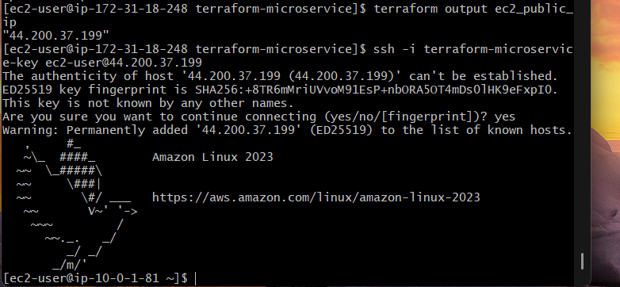

25.3 Check Docker
Run:
docker --version
You should get something similar to:
Docker version ...
Then:
sudo systemctl status docker
You want to see:
Active: active (running)
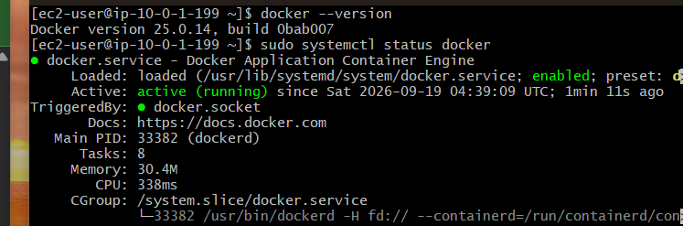

25.4 Check the container
Run:
docker ps
You should see a container similar to:
CONTAINER ID IMAGE PORTS
xxxxxxxx ...ecr.../terraform-microservice:latest 0.0.0.0:80->80/tcp
The important part is:
0.0.0.0:80->80/tcp
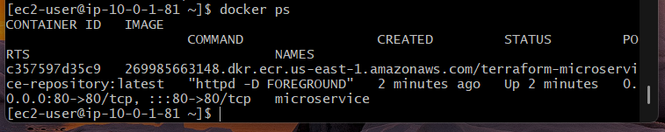
That means:
EC2 port 80
↓
Docker container port 80
↓
Apache

25.5 Test Apache locally on EC2
Run:
curl http://localhost
You should get:
<h1>Hello from Terraform Microservice!</h1>
<p>Application is running inside Docker on AWS EC2.</p>
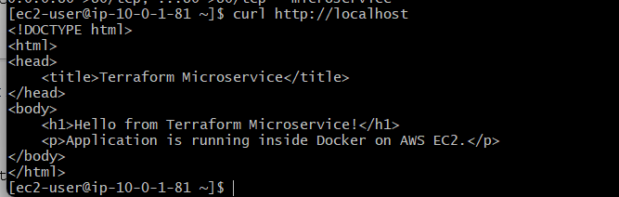
If you see that, your container is working.

26 — Test the Application Through ALB

26.1 Get the Load Balancer DNS name
First, exit the EC2 instance:
exit
You should return to your local machine.
Now run:
terraform output alb_dns_name
You should get something similar to:
terraform-microservice-alb-123456789.us-east-1.elb.amazonaws.com
This is your ALB DNS name.
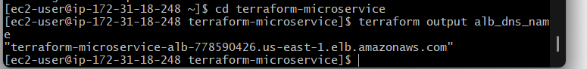

26.2 Test using curl
From your local machine, run:
curl http://$(terraform output -raw alb_dns_name)
You should receive:
<h1>Hello from Terraform Microservice!</h1>
<p>Application is running inside Docker on AWS EC2.</p>
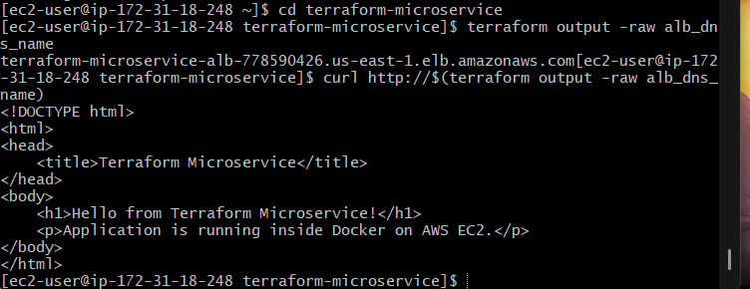
If you see your HTML page, the request successfully traveled through:
Your Laptop
|
| HTTP :80
v
+----------------+
| Application LB |
+----------------+
|
| HTTP :80
v
+----------------+
| EC2 |
| Docker |
| Apache |
+----------------+

26.3 Test in your browser
Copy the ALB DNS name:
terraform-microservice-alb-xxxxxxxx.us-east-1.elb.amazonaws.com
Open:
http://terraform-microservice-alb-xxxxxxxx.us-east-1.elb.amazonaws.com
You should see:
Hello from Terraform Microservice!
and:
Application is running inside Docker on AWS EC2.
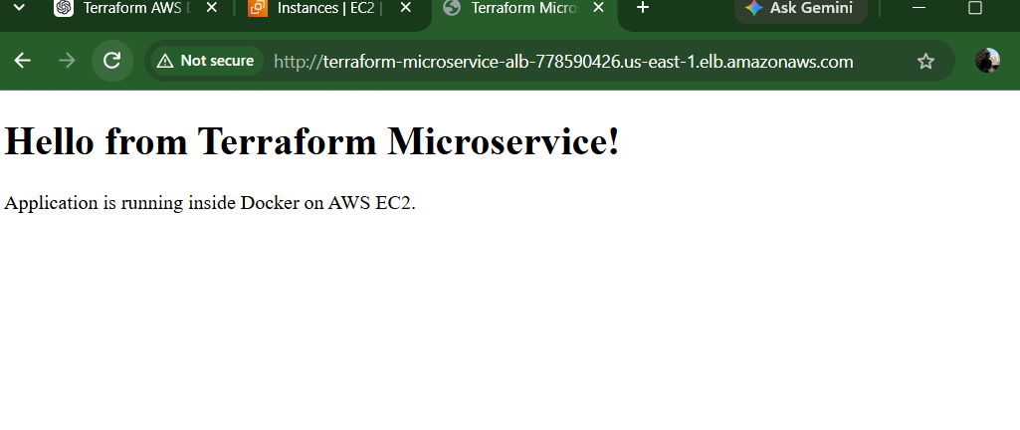

26.4 Check ALB Target Health
This is another important validation.
Go to AWS Console:
EC2 → Load Balancers → your ALB
Then:
Target Groups → your target group → Targets
You should see your EC2 instance with:
Health status: healthy
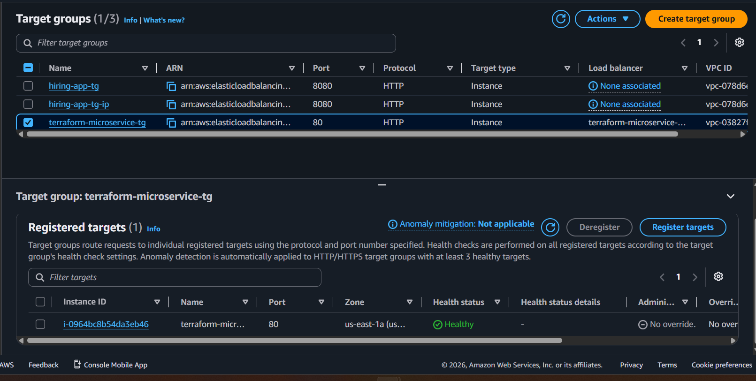
The flow is:
ALB
|
| Health check HTTP /
v
EC2:80
|
v
Docker container
|
v
Apache
|
v
HTTP 200
If the target is healthy, the ALB knows that your application is working.

26.5 Important Security Test
Now we need to verify that users cannot directly access the application through EC2.
Get your EC2 public IP:
terraform output ec2_public_ip
For example:
54.123.45.67
Try:
http://54.123.45.67
This should not return your application.
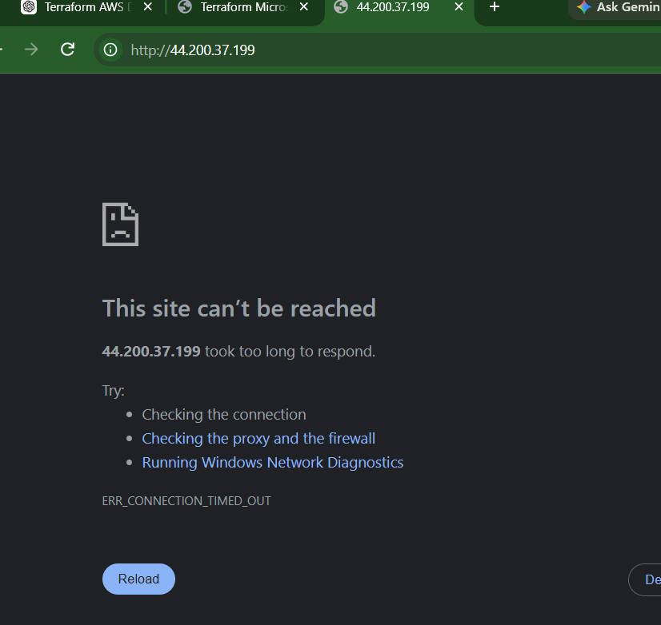
Why?
Our EC2 security group allows port 80 only from the ALB security group:
ingress {
from_port = 80
to_port = 80
protocol = "tcp"
security_groups = [aws_security_group.alb.id]
}
So:
Internet ─────X────> EC2:80
but:
Internet ─────────> ALB:80 ─────────> EC2:80
is allowed.

27 — Verify Security
Objective: Confirm that the EC2 instance is protected and the application is reachable only through the Application Load Balancer.

27.1 Get the EC2 public IP
From your Terraform project directory:
terraform output -raw ec2_public_ip
Copy the IP address.
Example:
54.xx.xx.xx

27.2 Test direct access to EC2
From your local machine, run:
curl --connect-timeout 5 http://<EC2_PUBLIC_IP>
Replace <EC2_PUBLIC_IP> with the actual IP.

Expected result
The request should fail or time out.
For example:
curl: (28) Failed to connect ... Connection timed out
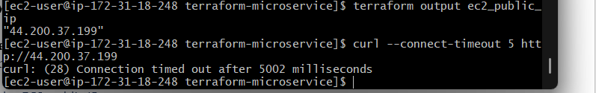
This is expected.
Why?
The EC2 security group allows:
Port 80 → Source: ALB Security Group
It does not allow:
Port 80 → Source: 0.0.0.0/0
So users on the internet cannot directly access Apache on EC2.

27.3 Verify SSH access
From your local machine:
ssh -i terraform-microservice-key ec2-user@<EC2_PUBLIC_IP>
You should successfully connect.
This confirms that port 22 is allowed from your configured ssh_allowed_cidr.
After connecting:
Exit
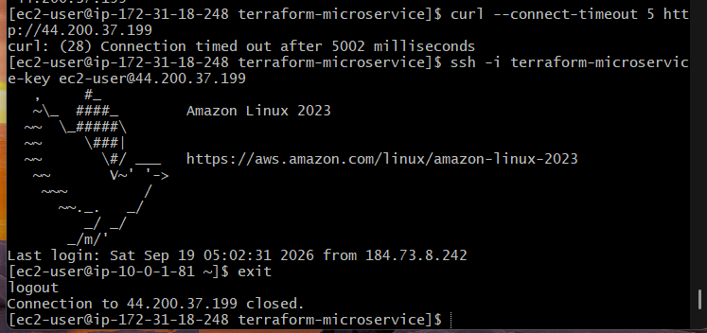

27.4 Verify the security architecture
Your final traffic flow should be:
Internet
|
| HTTP :80
v
+------------------+
| Application |
| Load Balancer |
+------------------+
|
| HTTP :80
v
+------------------+
| EC2 |
| Security Group |
+------------------+
|
| :80
v
+------------------+
| Docker Container |
| Apache :80 |
+------------------+

28 — Final Terraform Validation
Objective: Confirm that Terraform's state matches the AWS resources that were deployed.

28.1 Check Terraform state
From your Terraform project directory:
terraform state list
You should see resources such as:
module.network.aws_vpc.main
module.network.aws_internet_gateway.main
module.network.aws_subnet.public_a
module.network.aws_subnet.public_b
module.security.aws_security_group.alb
module.security.aws_security_group.ec2
module.ecr.aws_ecr_repository.app
module.compute.aws_instance.app
module.compute.aws_iam_role.ec2
module.alb.aws_lb.main
module.alb.aws_lb_target_group.app
module.alb.aws_lb_listener.http
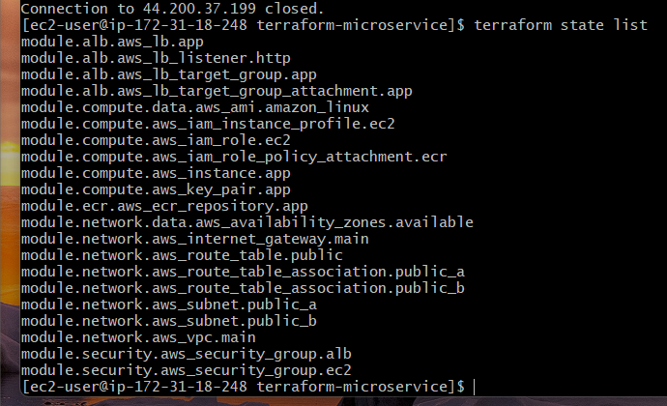
The exact list may differ slightly depending on the resource names in your files.

28.2 Run Terraform plan again
terraform plan

Expected result
Ideally:
No changes. Your infrastructure matches the configuration.
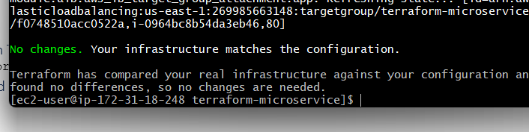
This confirms that Terraform is aware of the resources you created and there is no unexpected infrastructure drift.

28.3 Check outputs
terraform output
You should see values for things such as:
alb_dns_name
application_url
ecr_repository_url
ec2_instance_id
ec2_private_ip
ec2_public_ip
vpc_id
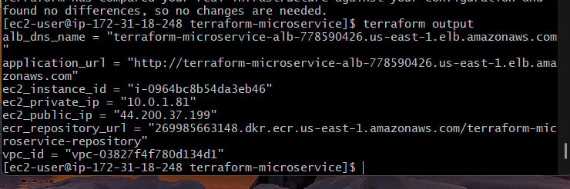

28. Terraform Dependency Flow
The overall Terraform dependency is:

VPC
|
+---------+---------+
| |
Security Groups Subnets
| |
| +----+----+
| | |
| ALB EC2
| |
| |
| IAM
| |
| ECR
| |
+------------------------+
More precisely:
ECR
|
| repository URL
v
EC2
|
| instance ID
v
Target Group
|
v
ALB Listener
|
v
ALB

29. Outcome
Outcome:
Successfully deploy a Dockerized static web application on an AWS EC2 instance using Terraform. The Docker image is built locally and stored in Amazon ECR, pulled by the EC2 instance, and executed as a Docker container. The Application Load Balancer provides the public entry point to the application, while the EC2 security group prevents direct internet access to the application port and permits SSH only from the specified IP address.

I have successfully deployed:
Internet
|
v
+----------------+
| ALB |
| HTTP :80 |
+-------+--------+
|
| HTTP :80
v
+----------------+
| EC2 |
| Amazon Linux |
+-------+--------+
|
v
+----------------+
| Docker Apache |
| :80 |
+----------------+

Docker Image
|
v
Amazon ECR

I created a modular Terraform codebase for deploying a containerized microservice on AWS. I created a VPC with two public subnets, an Internet Gateway and route table. I created Amazon ECR to store the Docker image. The application is a simple Apache web server running inside a Docker container. The EC2 instance has an IAM role with ECR read permissions, so it can authenticate and pull the image from ECR. I created separate security groups for the ALB and EC2. The ALB allows HTTP from the internet, while EC2 port 80 accepts traffic only from the ALB security group. SSH port 22 is restricted to my specific IP address. Finally, the ALB forwards requests to the Dockerized application running on EC2

